Framework Agreement for
Cleaning & Hygiene Supplies

REF EPP0006

- About EPP
EPP has over 12 years' experience providing successful frameworks for Public Sector Bodies across the UK.
We let and manage a number of simple and easy to use National Framework agreements that can be accessed by any UK Public Sector Body, from Land's End to John o' Groats, Lowestoft to Belleek! Please see the contract notice for a full list of who can use this framework.

- Overview
Start Date: | 1 February 2024
Expiry Date: | 31 January 2028
Contracting authority call-off periods | Contracting Authorities can specify a contract period up to 4 years, based on their needs.
FTS Contract notice ref no: | 2023/S 000-029778
Potential maximum value: | Lot 1 – up to £6.5 m  Sub-lot 2a – up to £1.5m  Sub-lot 2b – up to £1m  Sub-lot 2c – up to £500,000  Sub-lot 2d – up to £500,000
Rebate: | 1.5% paid by supplier
Geographical Coverage: | Lot 1 - National  Lot 2 - Regional
FTS Contract Award Notice: | 2024/S 000-005743

- Framework Scope
Goods available under the framework include cleaning and hygiene products, including but not limited to air care products, floor care/kitchen/washroom cleaning chemicals, emergency care, brooms and brushes, cleaning textiles and floor pads, hygiene paper, soaps and dispensers, gloves, sanitiser, detergents, chemicals, window cleaners, cleaning/janitorial equipment such as vacuums and pressure washers, PPE, pest control products and safety signs, divided into the following Lots:

- Lot 1 – National (including Scotland, Wales, and Northern Ireland)
- Lot 2 – Regional (England only)
Sub-lot 2a – London and East of England
Sub-lot 2b – Southeast and Southwest
Sub-lot 2c – East Midlands and West Midlands
Sub-lot 2d – Northeast, Northwest, and Yorkshire
- Why use This Agreement?
- Removes the need for a separate above threshold / FTS procurement process thereby significantly reducing timescales.
- Simple and easy to use. Choose either Direct Award or Further Competition
- Pre-agreed terms and conditions.
- Market leading suppliers have been assessed for their financial stability, professional and technical capability and experience.
- All suppliers are ISO9001 and ISO14001 certified
- Limited number of suppliers per lot to simplify your selection process.
- This framework is free for Public Sector Bodies to use and offers national coverage.

- Background to the Procurement

How EPP established the framework

- EPP has established the terms and conditions which will apply to any call-off arrangements by Public Sector Bodies during the period of the framework, EPP reserves the right in exceptional circumstances to vary the composition of the framework.
- A formal notice inviting suppliers to respond to this framework agreement was published in Find a Tender Service (or FTS) in 2023 (FTS ref 2023/S 000-029778)
- The procurement process adopted by EPP was based upon the open tendering procedure as detailed in the Public Contracts Directive 20014/24/EU.
- A detailed and thorough evaluation of the tenders that were submitted was completed by officers of EPP. The objective of the framework was not to promote one single preferred supplier but instead to offer a range of service solutions from a number of leading suppliers in the marketplace.

Evaluation Scheme for the framework

The Lots/Sub-Lots were awarded based on the most economically advantageous offer, taking into consideration the criteria in section 7. The award criteria was divided into two areas; quality and price and the specific weightings used were as follows:

- Price 55%
- Quality 45%

Standard Selection Questionnaire
Tenderers were required to submit a completed SSQ. Responses to the SSQ from the successful Tenderers were reviewed by EPP to establish if any of the exclusion grounds apply and to ensure that the minimum levels of suitability for the tender were met.

Minimum Standards
All responses were checked to ensure Minimum Standards (Quality and Environmental Management) were met prior to Evaluation. Responses that did not meet these standards were rejected as non-compliant.

Price Evaluation

Tenderers provided prices within a Pricing Schedule. The core products identified within the Pricing Schedule (Core List) were mandatory and formed the basket of goods for evaluation purposes. For each Lot/Sub-Lot, the Basket of Goods Total Value (Total Value) was entered into the model alongside the Total Value from all the submissions. The lowest Total Value received full marks and the remaining Tenders were scored according to their relationship with the lowest Tender.

Quality Evaluation
The Quality Criteria was scored by individual evaluators (formed of end users of the framework) evaluating the Tenderers’ corresponding method statement responses to the evaluation criteria. The evaluation panel came together with a moderator, to moderate scores and reach a consensus on each of the criteria.

The resultant price and quality scores were transferred across to the overall evaluation model where the weightings were applied to give total scores out of 100%.
- How to use This Framework

Public Sector Bodies will be permitted to Direct Award or conduct a mini competition under this framework for their individual requirements. Contracts are not exclusive; therefore, award to more than one supplier is permitted.

Option 1 – Direct Award

If Public Sector Bodies can justify value for money and provided their individual procurement procedure rules permit it, they will be able to call-off from this framework directly providing the reference number for this framework agreement. Customers will need to:
(a) identify the relevant Lot which their requirements fall into.
(b) identify the Framework Provider/s which meets its requirements and offers the most economically advantageous solution for those requirements following an evaluation of each Framework Providers’ Tender and the Pricing Matrices.
(c) send an Order/s to the Framework Provider/s.
The Pricing Matrices contain the list of products available for Direct Award and will be made available to Public Sector Bodies on request via completion of the Access Requirement Form. Where there is a colour variation and the required colour is not included in the Pricing Matrices, the pricing for this item will be the same regardless of the colour and therefore the colour variation can also be Direct Awarded.
Direct Awards can be made for ad-hoc requirements or for ongoing call-off contracts. The maximum period for Public Sector Bodies who may wish to call-off from the framework is 4 years.

So that Public Sector Bodies can make best-value decisions, suppliers have provided information about their organisations, which highlight their unique selling points (USP) and benefits or value added to Public Sector Bodies using this framework (see Section 13 in this User Guide).

Option 2 – Mini-Competition

Public Sector Bodies may wish to carry out a mini competition if their requirements differ from the framework specification, or if they require pricing information from Suppliers (where pricing is not in the Pricing Matrices) or wish to seek price improvements based on large volume contracts.

Mini-competitions can be carried out for ad-hoc requirements or for ongoing call-off contracts. The maximum period for Public Sector Bodies who may wish to call-off from the framework is 4 years.

Public Sector Bodies will be required to invite all Suppliers in the framework to mini competitions that are able to service their area. It is advised to give notice to Suppliers in advance of posting opportunities so they can be prepared.

Public Sector Bodies should use their own mini-competition templates and e-tendering systems.

All documentation must include the reference number for this framework agreement.

Public Sector Bodies carrying out mini-competitions must refer to Public Contracts Regulations 2015 (Regulation 33) if considering making variations to the call-off terms and conditions. Any variations required need to be added to the Variation section of the Call-off Order Form. Variations of call-off terms and conditions are not permitted for Direct awards.

Once the Public Sector Body has evaluated the further competition, an award notification must be sent to all relevant suppliers.

General

Public Sector Bodies may use their own or the BDC Call-off Order Form template for both ad-hoc requirements or an ongoing call-off contract.

The Framework Agreement and Call-off Terms and Conditions will apply to all purchases irrespective of their origin, and they must all include the reference number for this framework agreement.

The weighting used for the evaluation of the framework was 55% Price / 45% Quality for all Lots. A further breakdown of the specific criteria can be found in section 7 of this document. However, Public Sector Bodies may apply weightings that meet their needs for both Direct Award and Mini-competition.

Public Sector Bodies wishing to utilise this framework must advise EPP before undertaking a Direct Award or Mini Competition by completing and returning the Access Form – Appendix A – to EPP at ephframeworks@braintree.gov.uk

A copy of the generic Framework Agreement and the Call-Off terms and conditions and order form are available on request upon completion of the Access Form – Appendix A.

Once an award has been made, Public Sector Bodies must then complete the Award Notification Form – Appendix B – and return it to EPP at ephframeworks@braintree.gov.uk. They must also publish a Contract Award Notice on Contracts Finder.

- Framework evaluation criteria
Below is the detailed criteria used for evaluating the Framework responses:

Criteria / Sub Criteria | Marks | Weightings
Price – as per Pricing Matrices (Version 1) | /5 | 55%
Quality - as per sub-criteria below | /5 | 45%
Delivery of framework requirements | /5 | 15%
Environmental considerations | /5 | 10%
Customer service | /5 | 5%
Call-off contract performance management | /5 | 5%
Social Value | /5 | 10%
Quality Management – Minimum standard | Pass / Fail
Environmental Management – Minimum standard | Pass / Fail
GBS compliance declaration | Pass / Fail
Coverage and delivery | Pass / Fail
Management information and Performance Management | Pass / Fail

- Due Diligence

An assessment of economic standing was carried out on all Tenderers selected for appointment to the framework based on copies of the last three Financial Years of full company accounts.

All suppliers passed the Standard Selection Questionnaire element of the procurement process.

All suppliers provided evidence that they carried the following insurances:

- Employer’s Liability Insurance: £10,000,000
- Public Liability Insurance: £10,000,000
- Product Liability Insurance: £10,000,000

In order to retain a place in the framework, suppliers must provide reports and evidence to demonstrate continuing compliance as shown below to EPP annually on the anniversary of the commence date for the lifetime of the agreement:
- Insurance
- Annual accounts
- Compliance with Bribery Clause (also required 10 working days from commencement date)
- Sustainability Report
- Social Value Report
- Declaration that delivery drivers used directly or via transport companies are DBS certified and checked at the Supplier’s expense.

Furthermore, they must provide EPP with a Report of escalated Customer complaints twice a year in April and October.

Public Sector Bodies are responsible for ensuring that its own due diligence requirements are met. PSB’s may contact EPP for information on latest annual checks carried out but are invited to carry out any other due diligence or checks beyond the above list at the Call-Off stage if deemed necessary to meet own requirements and internal governance. Following its own financial stability assessments at tender stage, EPP recommends that PSBs carry out financial stability checks for any contracts likely to be above £1.5m in value.

- Suppliers per Lot/Sub-Lot and Contact Details
Supplier | Lot 1 | Lot 2a | Lot 2b | Lot 2c | Lot 2d
Alliance Disposables Ltd
Contact details:
Damian Chadwick
07384518445 damianchadwick@alliancelocal.co.uk
www.alliancenational.co.uk
Arrow County Supplies Limited
Contact details:
Penny Cudmore
01743 283600
Penny.Cudmore@arrowcounty.com and response@arrowcounty.com
www.arrowcounty.com
Bunzl UK Ltd T/A Bunzl Cleaning & Hygiene Supplies
Contact details:
Mike Barringer
01279 655544/ 07710 858 519
mike.barringer@bunzlchs.co.uk
www.bunzlchs.com
Nationwide Hygiene Supplies Limited
Contact details:
Rebecca Jackaman
01246 458 060/ 07706 313 863
rebecca.jackaman@nationwide-hygiene.com www.nationwide-hygiene.com
Pattersons (Bristol) Ltd.
Contact details:
Mark Silcocks
0117 9341270 / 07966 380927 mark.silcocks@pattersons.co.uk www.pattersons.co.uk

- Pricing
Framework Pricing for Direct Award purposes is available on request (see Appendix A)
Any pricing and details provided under this agreement are commercially confidential and must not be shared with any third party.

In particular, prices must under no circumstances be shared with other suppliers on or off the agreement, in an attempt to improve the price, or for any other reason.

The current framework pricing is Version 1 - 1 February 2024.

- Ordering and Managing call-off Contracts

E-Procurement and Ordering
All Suppliers have the capacity to accept Purchase Orders electronically. A Supplier awarded a contract will be required to provide at a minimum an e-mail account for the receipt of orders and an electronic catalogue or access to a “punch-out” facility for use with a range of P2P solutions.
Some public sector bodies may use the latest version of UNSPSC (Universal Standard Product and Services Classification), to classify ordered products for management information purposes. Suppliers will be able to code their products to UNSPSC to conform to this requirement upon request
Options for placing Purchase Orders

The method of placing purchase orders will vary from Customer to Customer:

- Customers may use P2P systems.

- Should customers prefer to order through the Supplier’s websites, the Suppliers will ensure that mapping is put in place so that the order links back to this framework agreement, ensuring Customers have access to the pricing agreed.

Catalogues
Suppliers are required to keep data up to date by providing information as needed for electronic catalogues, IDeA Marketplace and other systems.
Public Sector Bodies may require the Suppliers to provide an electronic catalogue of the agreed products and the Suppliers are expected to maintain the content of the catalogue at their own cost.
Contract Management

For Framework and Call off Contract Management, please refer to the framework agreement (available on completion of Appendix A).

- Contractual Structure

A Public Sector Body wishing to procure using the framework (the Customer) will enter into a contract for the supply of cleaning and hygiene supplies based on the pre agreed terms and conditions of contract.

Whilst these pre-agreed terms and conditions may be amended by Public Sector Bodies conducting a further competition; any such amendments must not vary substantially from the original terms agreed and must be communicated to suppliers on the framework at the start of the further competition process, i.e. when the Invitation to Tender is issued.

It is anticipated that day to day transactions (including undertaking further competitions, the appointment of suppliers and delivery of and payment for supplies) will be conducted directly between customer and supplier.

The contract structure diagram shown in Fig.1 illustrates the relationship between parties to the arrangement.

Fig.1

ACCESS AGREEMENT
CUSTOMER
EPP

FRAMEWORK AGREEMENT
CALL OFF TERMS

SUPPLIER

- Additional Supplier Information

Alliance Disposables Ltd
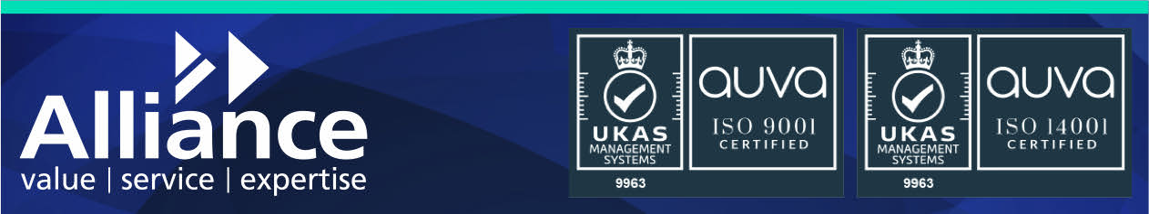
“Alliance is one of the UK and Ireland's leading suppliers providing over 20,000 branded products , 10,000 which we stock, across janitorial and non-food catering supplies. Established in 1999 our founders aim was to create a different sort of company, one which was dedicated to serving its customers and with flair and fairness, placing their happiness as our key focus.

The Alliance strategy was to set up a large national distribution operation and complement that with strategically located regional branches across the UK. Providing a genuinely local, customer focused service.

In 2021, Alliance became an employee-owned trust meaning each employee is a shareholder in the business and receives a profit-based dividend each year. The directors ensured that an executive team was set up to manage the day-to-day operations of the company whilst also planning the long-term strategy of the company.

Unlike other suppliers, we do not pass members onto manufacturers, our sales and customer support teams find appropriate solutions and have those in-depth technical discussions with our upstream supply base on members behalf, so that they have one consistent point of contact, helping to support efficient and satisfactory conclusions.

As a business we are actively looking to review and improve our environmental operations throughout our full infrastructure network. We are committed to our own set national carbon net zero targets. We own all our vehicles and have started an internal programme to replace all diesel/petrol vehicles with over fifty electric vehicles purchased in 2023.

Key Benefits of Alliance

Furthermore, being a customer of Alliance has the following benefits:
• Credit Facility - With a trade account you get up to 30 days credit to help you manage the cashflow of your business.
• Bespoke Pricing - Get a trade price list which is bespoke to your business giving you additional savings on what you regularly buy.
• Personal Account Handler - Our friendly and knowledgeable team are on hand to give you the best levels of service and expertise in the industry.
• Rapid & Reliable Delivery - Because we are local to your business our own fleet of delivery vehicles are primed and ready to get you what you want - fast!
• Fast Samples - Product samples quickly delivered so you can compare quality, design and suitability for your business environment.
• Product Sourcing - As well as our extensive range of brands, our specialist team can source specific and unusual products for your business.
• Support & Backup - You will get the full support and backup of the local Alliance resource and expertise.

At Alliance we pride ourselves on providing all customers no matter how large or small they may be with value, service and expertise. These core principles have always been key to our operations from order to delivery and every step in between and will continue to be for as long as we trade..”

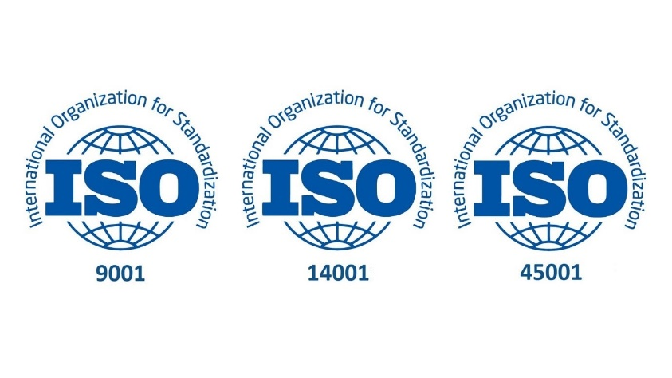
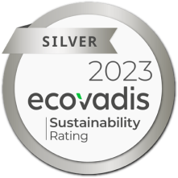
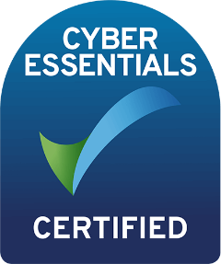
Bunzl UK Ltd T/A Bunzl Cleaning & Hygiene Supplies

“Bunzl Cleaning & Hygiene Supplies is the UK's leading janitorial, cleaning, and hygiene products supplier. We are part of Bunzl PLC, one of the fastest-growing FTSE100-listed global distribution and outsourcing groups. We source cleaning and hygiene products and ensure they are delivered on time so facilities management teams can create clean and safe environments that protect people while away from home.

Our customers benefit from our years of knowledge and expertise in the cleaning and hygiene sector. Our national branch network of 18 unique and strategic locations and a dedicated customer service hub gives us total coverage of the United Kingdom, from Cornwall to Aberdeen and everywhere in between.

We prioritise innovation and sustainability to help our customers create clean, safe workplaces and communities. Our Exclusive Brands product range focuses on reducing plastic content in both product and packaging and incorporating recycled materials and end-of-life recyclability.

Our Advantage platform is an efficient online e-ordering solution that offers a seamless user experience, exceptional service, and high-quality products. With user logins and control features, customers can ensure they buy at the best price whenever they place an order. The customer administration dashboard allows for the customisation of product ranges and restrictions, reducing administrative costs and putting customers in control of product access, budgets, and users.

We are committed to achieving Net Zero by 2050 by reducing emissions from our deliveries, offsetting what we cannot change yet, and introducing innovative products and solutions to drive industry change.

We have three Sustainable Solutions to help us achieve our Net Zero goals. Carbon Forecast calculates and offsets carbon emissions from deliveries. We can provide bespoke Carbon Forecast reports to demonstrate how small changes make a big difference and help you offset remaining emissions through verified schemes. The BCHS Product Award system assigns Gold, Silver, and Bronze awards to highlight sustainable products. Recycle Connect aims to increase recycled content in packaging and test closed-loop solutions. We can discuss these solutions further and other innovations like Tork's Vision Cleaning and PaperCircle hand towel recycling programs.

BCHS values diversity and inclusion, demonstrated through internal ED&I networks like Inspiring Women in Bunzl and Inspiring Ethnicity in Bunzl. We value collaboration and inclusivity at BCHS and believe our values align well with yours.

We offer flexible ordering, delivery, and invoicing solutions to meet your specific needs. Whether you prefer online or telephone ordering, multiple-drop or bulk deliveries, or consolidated or individual invoicing, we can accommodate you.”

Nationwide Hygiene Supplies
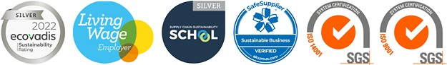

“Nationwide Hygiene Supplies is an integrated network of more than 18 Members across the UK and Ireland with more than 25 local depots as well as having partnerships across Europe and the United States. This provides the collective strength of all our member businesses, with the simplicity of working with just one. By unlocking the best of both worlds, we can bring you the benefits of national scope and scale, supported by a personalised local service fulfilled by SMEs.
From the start – we put you first, every step of the way. We will work with you to supply what you need, when you need it. And we'll always go that extra mile to offer the best choice, solutions, and value, backed by a service that's tailored around you.
We are proactive in our approach of adding value, and specifically focus on 6 keys areas which we deliver to our customers ensuring we maintain the highest standards of professionalism. We commit to supporting your business:
- Reporting
- We create monthly MI reports at both a national and a local level, however we have the ability to bespoke any reporting to ensure it is suitable for your and the end user needs, that it provides meaningful information and clearly creates a dashboard of actions.
- Innovation
- As industry experts we are committed to share with you new products and solutions. Our approach includes sharing marketing materials, samples of products and features and benefits of each against products currently in use. We also provide local analysis of these against products currently in use, whether this be the cost savings or a sustainability benefit such as plastic or carbon reduction.
- Sustainability
- Carbon emission reporting
- Plastic reduction
- Local sourcing
- Social activities
- Training & Support
- Dedicated account management team
- Joint business plans addressing your key objectives.
- Marketing support
- Bespoke Training Task Cards and Training Tools
- Savings & Efficiencies
- ‘Switch & Save’
- Driving cost reductions
- Online ordering platform with budget and control mechanisms
- Products & Delivery
- 18 members with 25+ depots across UK, Ireland, and Channel Islands
- Our partner suppliers offer major brands across our product categories.
- Deliveries made by employed drivers in liveried vehicles.

Due to our flexible and adaptable model we pride ourselves on our service delivery, meeting local site delivery requirements to ensure security of supply. As well as our ISO accreditations we also hold sustainability accreditations with Ecovadis and Alcumus, work with the Supply Chain Sustainability School and UN Global Compact and we are proud to be a Living Wage Employer.”
Arrow County Supplies Limited (Sub-Lots 2a, 2b, 2c, 2d)

“Driving additional benefit to our customers is at the heart of the ‘Arrow Way’. Our range of Unique Selling Points (USPs), Framework-specific benefits and green credentials, assisting customers in making a Direct Award. Key benefits include:

- Online ordering via our exclusive portal: Our market-leading customer portal enables end-to-end management Arrow Connect of contract spend, reporting and ordering, including the following USPs:
- Contract-specific digital catalogue, limiting purchaser choice to preauthorised catalogue of goods (eliminating off-contract expenditure).
- Site-specific budgets, ensuring maximum spend compliance.
- Tiered user access, with ability set bespoke permissions for each user
- Shopping list function for favourite products (more efficient ordering).
- Live-stock visibility, with users able to see item availability, alternatives and stock replenishment estimations. Integration capability with a range of P2P/PunchOut solutions.

- Arrow Academy Training Programme: Arrow provide tailored training programmes to ensure correct product use and legislative compliance, e.g. COSHH. This includes:
- Tailored BICSc-level product/COSHH training courses
- Train the Trainer programme, for flexible training delivery/staff upskilling
- Management of training schedules to ensure ongoing compliance.
- Provision of multi-lingual training resources
- Creation/supply of bespoke chemical wallcharts (see Appendix 10).

- WorkSmarter Programme: Unique onsite assessment program, helping Customers improve cleaning practice and ensure they are using the ‘best products for the job’ through detailed 4-stage review.
- Managed stock and inventory services, using our integrated, sophisticated stock management systems to pre-position and forward-ringfence stock for individual Customers – providing guaranteed fulfilment and rapid delivery.
- Exclusive innovations range, driving cleaning performance and efficiency through our Green Care sustainable chemical range (offering market-leading sustainability credential performance/impact tracking); SlipStop® leak collector (providing efficient leak-collection and minimising health and safety risks); and over 200 innovative Andarta® own-brand products (including our Eliminator® chemical range; SuperSmart Niche Brush; SynergySmart dispensing systems).
- Green Credentials: Arrow have strong Green credentials (ISO:14001/EcoVadis Gold), managing leading green initiatives including our ‘Carbon Impact’ emissions reduction programme; Greenleaf product sustainability programme and dedicated social impact budgets. Our ‘For Humanity’ Social Value programme closely aligns with the Public Services (Social Value) Act 2012, providing a strong framework to drive added social value to framework Customers – successfully leading delivery of £400,000 equivalent social value benefit in 2022-2023.”

Pattersons (Bristol) Ltd. (Sub-Lots 2b, 2c)
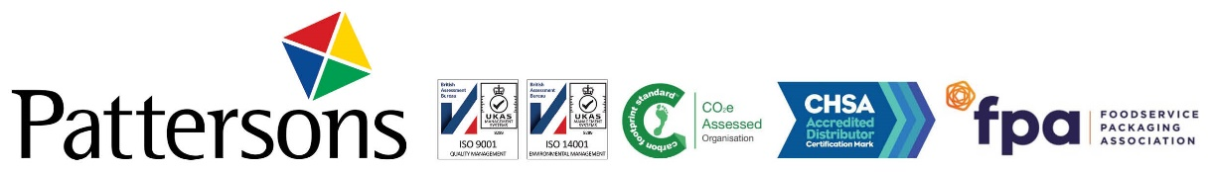
“With regional distribution hubs in Devon, Bristol, West Midlands and Greater Manchester and local face to face account management on the road, Pattersons have since 1889 been trusted to offer fit for purpose cleaning products with a service that’s hard to beat.
Carbon neutral certified, Pattersons are predominantly specialists in supplying cleaning products, janitorial equipment, and consumables, with specialist departments that look after customers in the accommodation sector and those in catering and hospitality. Trading since 1889, Pattersons is the largest independent cleaning products supplier in the Southwest, which is still family run to this day.
Stocking over 8000 lines available for immediate delivery, the company also benefits from being the largest member of the Jangro Network, a dynamic and innovative force in the cleaning supply industry. Membership of this group means Pattersons can offer their customers, a wealth of product innovation, first to market products as well as full specialised training courses in cleaning via the group’s Learning Management System.
Diversey, Ecolab, Delphis Eco, BioHygiene, Jangro, SYR, Katrin, Tork, and Robert Scott are just a few of the UK’s leading cleaning brands the company stocks ready for immediate delivery. The great relationships Pattersons has with its suppliers benefits its customers by ensuring they are at the forefront of innovation and first to market with new products, services, and technical support.
Pattersons distribution hubs are well positioned, with local employees who understand each geographical areas requirements fully, as well as having extensive knowledge of the cleaning and janitorial market. This means fast, efficient delivery whilst minimising carbon emissions in transit, with many hubs offering an emissions free delivery service, and all deliveries are made on the Pattersons’ fleet by employed drivers.
Supplying products as agreed in the contract at the price agreed, Pattersons will also provide add on services such as product training, full reporting and bringing innovation to the table, with a focus on sustainability, and product rationalisation to reduce costs in the long-term.
All of Pattersons’ customers are assigned an Account Manager to oversee the delivery of products to order, ensuring that Pattersons continues to offer a first-class service as it’s done since 1889, with a focus on the future by adding social value to the areas it operates in, whilst increasing sustainability to ensure the company continues to operate for another 130 years, maintaining its carbon neutral accreditation as awarded since 2022.
Pattersons excels at offering a consultive solution approach to projects, particularly those where the core focus is sustainability in cleaning and works with its partners to achieve mutually beneficial projects that save costs though rationalisation, increase sustainability through lowering carbon emissions or eliminating single use plastics in the supply chain. By working with Pattersons, companies can demonstrate their environmental accreditation by choosing a supplier with a strong ethos towards being eco-conscious, who can demonstrate their commitment though previous case studies, reports and accreditation achieved.”

- If You Require Further Information:

E: Email us at ephframeworks@braintree.gov.uk
T: Call us on 01376 551414 and ask for Procurement
W: Visit our website at www.ephframeworks.org
S: Follow us on LinkedIn @EPH Frameworks

Public Sector Bodies having any difficulties with contracts placed under this Agreement which cannot be solved simply, should contact us for assistance.

Appendix A – EPP Framework Access Form

Public Sector Bodies wishing to utilise this framework must advise EPP before undertaking a Direct Award of Mini Competition by completing and returning this form EPP via ephframeworks@braintree.gov.uk. Alternatively, please complete this form via this link.

Framework name and reference
Lot/Sub-lot number to be used
Please indicate if you are planning to Direct Award or carry out a Mini-competition | Direct Award Mini-Competition  ☐ ☐
Estimated Contract Start Date
Estimated Contract Duration
Do you require a copy of the Pricing Matrices? | Yes No  ☐ ☐
Do you require a copy of the generic Framework Agreement template and call-off Terms and Conditions and order form? | Yes No  ☐ ☐
Declaration:
By submitting this form, I confirm that our organisation wishes to access the below indicated framework agreement, and that in doing so, it will act in accordance with the relevant User Guide and will follow Public Contracts Regulations 2015 where applicable.

I acknowledge that suppliers’ pricing under the framework agreement is commercially sensitive information and agree, on behalf of our organisation, to keep the pricing information supplied to us in strict confidence. This is not to be disclosed to any other party. I shall not make any use of any information provided other than for accessing the framework. Any information provided will only be shared with stakeholders reasonably required to receive it.

I acknowledge that any purchases made under this framework agreement will form a contract directly between us the purchaser, and the individual framework contractor.

Name of Your Organisation
Your Name
Your E-mail
Signature

☐ Tick this box if you would not like to join our mailing list. You will only hear from us a few times a year, to advertise new Frameworks that have been let, or any changes to existing Frameworks.

Appendix B – EPP Award Notification Form

Public Sector Bodies must complete the following details on contract award:

Framework name and reference
Awarded Supplier
Supplier Contact Name
Value of Contract
Lot/Sub-lot number
Direct Award or Mini-competition | Direct Award Mini-Competition  ☐ ☐
Contract Start Date
Contract Completion Date or number of years awarded, or please state if this is an ad-hoc requirement
Name of Your Organisation
Your Name
Your E-mail
Signature

Please return this form via e-mail to: ephframeworks@braintree.gov.uk. Alternatively, please complete this form via this link.

